Lab Exercise - Azure Traffic Manager using Cloud Shell

Objective
In this lab you will:
- Create two Azure VMs in different regions
- Install Apache Web Server
- Create Azure Traffic Manager profile
- Configure endpoints
- Test DNS-based traffic routing
- Simulate failover

Architecture
Users
|
Azure Traffic Manager
|
-----------------------------
| |
VM1 (East US) VM2 (West US)
Apache Server Apache Server

Step 1: Open Azure Cloud Shell
Open:
Azure Portal
Open Cloud Shell and select Bash.

Step 2: Define Variables
RESOURCE_GROUP_EAST="tm-east-rg"
RESOURCE_GROUP_WEST="tm-west-rg"
LOCATION1="eastus"
LOCATION2="westus"
VM1="east-vm"
VM2="west-vm"
USERNAME="azureuser"
TM_PROFILE="myTrafficManager"
DNS_NAME="mytm$RANDOM"

Step 3: Create Resource Groups
East US
az group create \
--name $RESOURCE_GROUP_EAST \
--location $LOCATION1

West US
az group create \
--name $RESOURCE_GROUP_WEST \
--location $LOCATION2

Step 4: Create VM in East US
az vm create \
--resource-group $RESOURCE_GROUP_EAST \
--name $VM1 \
--image Canonical:0001-com-ubuntu-server-focal:20_04-lts-gen2:latest \
--size Standard_B1s \
--storage-sku Standard_LRS \
--admin-username $USERNAME \
--generate-ssh-keys \
--public-ip-sku Standard

Step 5: Create VM in West US
az vm create \
--resource-group $RESOURCE_GROUP_WEST \
--name $VM2 \
--image Canonical:0001-com-ubuntu-server-focal:20_04-lts-gen2:latest \
--size Standard_B1s \
--storage-sku Standard_LRS \
--admin-username $USERNAME \
--generate-ssh-keys \
--public-ip-sku Standard

Step 6: Open HTTP Port on Both VMs
VM1
az vm open-port \
--resource-group $RESOURCE_GROUP_EAST \
--name $VM1 \
--port 80

VM2
az vm open-port \
--resource-group $RESOURCE_GROUP_WEST \
--name $VM2 \
--port 80

Step 7: Install Apache on East VM
az vm run-command invoke \
--resource-group $RESOURCE_GROUP_EAST \
--name $VM1 \
--command-id RunShellScript \
--scripts "
sudo apt update
sudo apt install -y apache2
echo '<h1>Welcome from EAST US VM</h1>' | sudo tee /var/www/html/index.html
sudo systemctl restart apache2
"

Step 8: Install Apache on West VM
az vm run-command invoke \
--resource-group $RESOURCE_GROUP_WEST \
--name $VM2 \
--command-id RunShellScript \
--scripts "
sudo apt update
sudo apt install -y apache2
echo '<h1>Welcome from WEST US VM</h1>' | sudo tee /var/www/html/index.html
sudo systemctl restart apache2
"

Step 9: Get Public IP Addresses
East VM IP
EAST_IP=$(az vm list-ip-addresses \
--resource-group $RESOURCE_GROUP_EAST \
--name $VM1 \
--query "[0].virtualMachine.network.publicIpAddresses[0].ipAddress" \
-o tsv)
echo $EAST_IP

West VM IP
WEST_IP=$(az vm list-ip-addresses \
--resource-group $RESOURCE_GROUP_WEST \
--name $VM2 \
--query "[0].virtualMachine.network.publicIpAddresses[0].ipAddress" \
-o tsv)
echo $WEST_IP

Step 10: Verify Websites
Open in browser:
http://EAST_IP
You should see:
Welcome from EAST US VM
Open:
http://WEST_IP

You should see:
Welcome from WEST US VM

Step 11: Create Traffic Manager Profile
az network traffic-manager profile create \
--resource-group $RESOURCE_GROUP_EAST \
--name $TM_PROFILE \
--routing-method Priority \
--unique-dns-name $DNS_NAME \
--ttl 30 \
--protocol HTTP \
--port 80 \
--path "/"

Step 12: Add East VM Endpoint (Primary)
az network traffic-manager endpoint create \
--resource-group $RESOURCE_GROUP_EAST \
--profile-name $TM_PROFILE \
--name east-endpoint \
--type externalEndpoints \
--target $EAST_IP \
--endpoint-status Enabled \
--priority 1

Step 13: Add West VM Endpoint (Secondary)
az network traffic-manager endpoint create \
--resource-group $RESOURCE_GROUP_EAST \
--profile-name $TM_PROFILE \
--name west-endpoint \
--type externalEndpoints \
--target $WEST_IP \
--endpoint-status Enabled \
--priority 2

Step 14: Get Traffic Manager DNS Name
az network traffic-manager profile show \
--resource-group $RESOURCE_GROUP_EAST \
--name $TM_PROFILE \
--query dnsConfig.fqdn \
-o tsv

Example Output:
mytm12345.trafficmanager.net

Step 15: Test Traffic Manager
Open browser:
http://<traffic-manager-dns-name>

You should see:
Welcome from EAST US VM

Because Priority routing sends traffic to primary endpoint.

Step 16: Simulate Failure
Stop East VM:
az vm stop \
--resource-group $RESOURCE_GROUP_EAST \
--name $VM1

Wait 2–5 minutes for health probe detection.

Refresh browser:
http://<traffic-manager-dns-name>

Now you should see:
Welcome from WEST US VM

This demonstrates automatic failover.
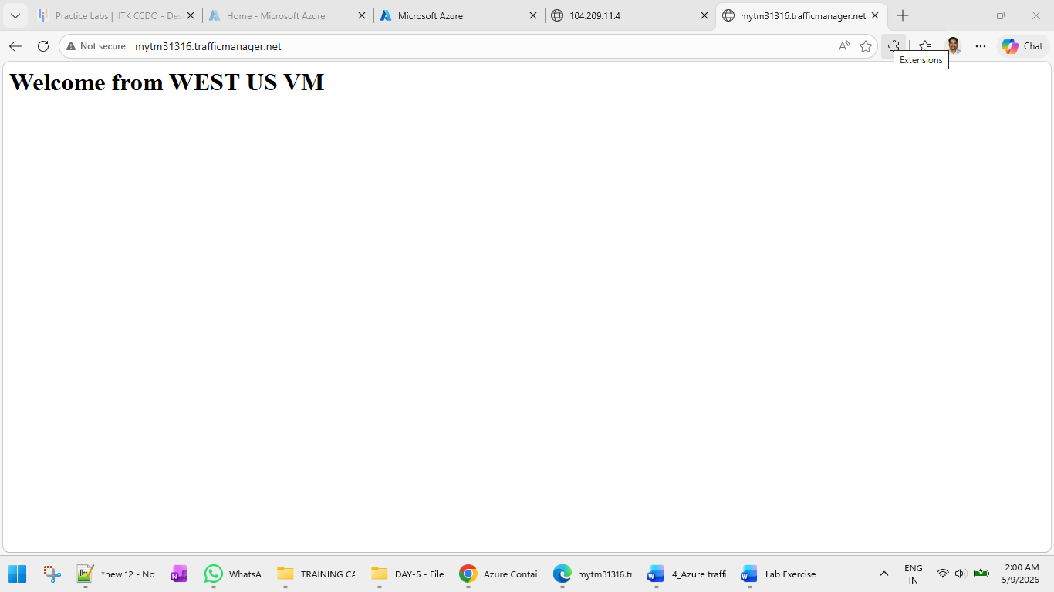

Step 17: Start VM Again
az vm start \
--resource-group $RESOURCE_GROUP_EAST \
--name $VM1

Traffic will eventually return to primary endpoint.

Verification Commands
Show Traffic Manager Profile
az network traffic-manager profile show \
--resource-group $RESOURCE_GROUP_EAST \
--name $TM_PROFILE

Show Endpoints
az network traffic-manager endpoint list \
--resource-group $RESOURCE_GROUP_EAST \
--profile-name $TM_PROFILE \
-o table

Test DNS Resolution
nslookup $(az network traffic-manager profile show \
--resource-group $RESOURCE_GROUP_EAST \
--name $TM_PROFILE \
--query dnsConfig.fqdn \
-o tsv)

Cleanup Resources
Delete East Resource Group
az group delete \
--name $RESOURCE_GROUP_EAST \
--yes \
--no-wait

Delete West Resource Group
az group delete \
--name $RESOURCE_GROUP_WEST \
--yes \
--no-wait

Expected Learning Outcome
After completing this lab, you will understand:
- Azure Traffic Manager architecture
- DNS-based load balancing
- Global traffic routing
- Priority routing method
- Health monitoring
- Automatic failover
- Multi-region deployment concepts

